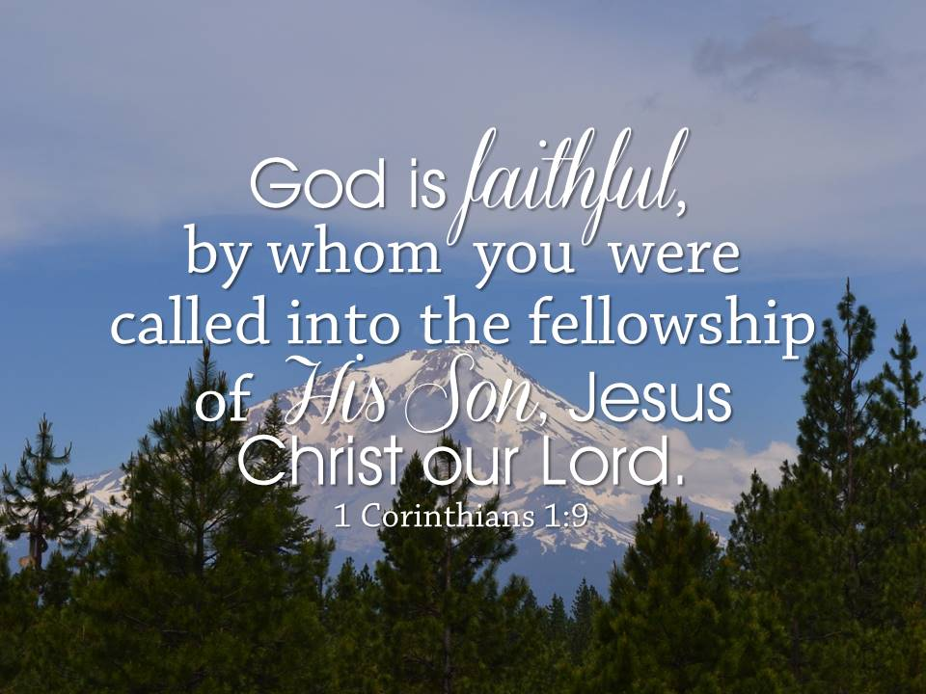

Wait For It

St. Paul Lutheran Church
Lutheran Church—Missouri Synod
Columbus, Indiana

Announcements for Thanksgiving Eve
and First Sunday in Advent
November 25 and 29, 2020

Welcome to St. Paul!
We are glad that you have come to God’s house to be fed and strengthened by His holy Word. The order of service for today is printed on the insert in this bulletin. Guests, we extend a special welcome to you this morning. If you are visiting with us, please include your name and address on the Record of Fellowship found at the end of each pew. We are privileged to have you as our guest today and encourage you to worship with us again soon.

The Family Quiet Room and Restroom are located outside the doors of the sanctuary and to the left. In the Family Quiet Room, you can hear and see the service. Assisted hearing devices are available for the service. Please contact an usher.

Do you need prayer support? Please call Bonnie England at 812-392-2732 to activate our Prayer Chain. Your fellow church members will pray for you.

Our Communion Practice: Scripture teaches that the bread and wine are the true body and blood of Jesus Christ, and that through this Sacrament God grants us the forgiveness of sins and strength for our faith. Holy Scripture reminds us in 1 Corinthians 11:27-34 that those who eat and drink our Lord’s body and blood in an unworthy manner do so to their great harm. It is out of love and care for each individual that comes to the Lord’s Supper that we ask that those who hold a different belief or church membership than that of the Lutheran Church—Missouri Synod, are not instructed and confirmed in the faith, or doubt the presence of Christ and His power in the Sacrament to refrain from attending the Lord’s Supper. Please respect our position of love in this matter of pastoral care and speak with the pastor with any questions regarding the Lord’s Supper. Communion Preparation: To prepare for the Lord’s Supper, you may wish to pray the prayer on the inside cover of the hymnal or review the Christian Questions and Answers on pages 329-330.

Christian Education Opportunities
Today at 9:30 AM—Advent Advent-ures! We will begin in the sanctuary with opening devotions and singing Christmas carols for our shut-ins. Families with young children will then do advent activities and Pastor Bauman will lead an advent study in the sanctuary.
Nursery is available for children under three on Sundays.
Regular Sunday School resumes next Sunday.

Wednesdays at 9 AM Adult Bible Study on Jeremiah.
Wednesdays at 6 PM Adult Bible Study on Luke.

Serving Today
Organist: Kantor Dan Mau
8 AM Acolyte: Owen Arnholt
10:45 AM Acolyte: Amelia Justis

Church Calendar
Sunday 11/29 8:00 AM Divine Service
8:30 AM Radio Service 98.1FM/1010AM
9:10 AM Fellowship
9:30 AM Together as Family
10:45 AM Divine Service/English and
Spanish
Noon Spanish Bible Study
12:15 PM Youth Confirmation
2:00 PM Small Group Communion
Tuesday 6:30 PM Girl Scouts
Wednesday 9:00 AM Bible Study
4:45 PM Advent Communion Service
6:00 PM Bible Study
6:00 PM Handbells Rehearsal
7:00 PM Advent Service
7:45 PM Sr. Choir Rehearsal
Thursday 6:00 PM Boy Scouts
7:00 PM Tri-W Meeting
Friday Church Reserved
Saturday Church Reserved
Saturday 8:00 AM Church Decorating
Sunday 12/6 Mite Box Sunday
8:00 AM Divine Service
8:30 AM Radio Service 98.1FM/1010AM
9:10 AM Fellowship
9:30 AM Sunday School
10:45 AM Divine Service/English and
Spanish
Noon Convivio
12:15 PM Youth Confirmation
1:15 PM Choristers
2:00 PM Small Group Communion

ANNUAL MEETING PACKETS, DECEMBER NEWSLETTERS AND LUTHERAN WOMEN’S QUARTERLY…. are available in the gathering space. The newsletter is also posted on our website.

MEMORY VERSE FOR THE WEEK… Comfort, comfort My people, says your God. Speak tenderly to Jerusalem, and cry to her that her warfare is ended, that her iniquity is pardoned, that she has received from the Lord’s hand double for all her sins. Isaiah 40:1-2

POINSETTIA DEADLINE… is Sunday, November 29th. Please use the form included in this bulletin.

IN OUR PRAYERS… Jim Newton, Juana Soto, Ron Hoevener, Rosemary Albright, Nora Heath (Sally Haak’s mother), Jeff Tucker (Justin’s father), Emmie Brooks (Emily Vogel’s classmate), Tim Isley (Haak’s former neighbor), Chris Hiatt (Jennifer Dettmer’s brother), Rick, Amy, and Ryan Gilliam (Cleary’s neighbor), Teresa Palmer (Doris Grayson’s granddaughter), Mark Moore (Doris Grayson’s son-in-law), Julie Phillips (Bonnie Nolting’s sister), Evelyn and Rich Sapper (Nora Cleary’s sister and brother-in-law), Fran Sapper (Cleary’s friend), Connie Ball (Jan Voelz’s friend).

PRAYER LIST UPDATE… The prayer list has been updated this past week. If you or someone you placed on the prayer list has been removed but is still in need of our prayers, please contact Jackie Arnholt or one of the pastors and we will place them back on the prayer list.

ADVENT ADVENTURES: TOGETHER AS FAMILY DAY… We will gather together on Sunday, November 29th at 9:30 AM to focus on the coming of Christ during this Advent season. Since in-person Christmas caroling cannot occur this year, we will begin in the sanctuary where attendees will sing Christmas carols which will be recorded. Pastor Bauman will show the video to our shut-ins when he visits them in December. In addition, devotional materials will be distributed to families along with participating in activities that enrich the celebration of Advent at home. Please plan to attend!

SMALL GROUP COMMUNION SERVICES… are offered every Sunday at 2 PM.

MIDWEEK ADVENT SERVICES… O Lord, How Shall I Meet You, How Welcome You Aright? Using Hymn 334 in the LSB Hymnal as the theme hymn, we will look at how people welcomed the coming Savior and apply how they welcomed Jesus to how we are (and in some cases, how we are not) to meet and welcome Jesus. Midweek Advent Services will be held at 4:45 and 7 PM on Wednesdays, December 2nd, 9th, 16th, and 23rd. The 4:45 PM service will offer Communion and will be live-streamed.

BETHLEHEM WALK… Prince of Peace Lutheran Church, 3496 East Morgan Street,, Martinsville, will present its Seventh Annual Bethlehem Walk on Saturday, December 5th from 5-8 PM. The walk will be self-guided, in small groups that will be released in 10-minute increments. Tickets are free, but must be reserved. For more information, please call: 765-342-2004 or email popchurchlcms@hotmail.com.

LUTHERAN CHILD AND FAMILY SERVICES… On Sunday, December 6th, Brady Gurganious from Lutheran Child and Family Services based in Indianapolis will have a display and gathering space and speak at the beginning of Bible study about their important work.

ADVENT SERVICE OF SONG… On Sunday, December 13th at 8, 9:30, and 11 AM, please join us for a special Advent Service of Song. The services will include our adult and children’s choirs as well as a string quartet and trumpet. The service will focus on our Advent and Christmas theme: “O Lord, How shall I meet You?” Please plan to attend and invite others. There will be no Sunday School or fellowship hour on December 13th.

LAS POSADAS SERVICE… On Saturday, December 19th at 5 PM, our Latino outreach will be hosting Las Posadas Service. This is a traditional service in Latin America that recounts Mary and Joseph’s difficulty in finding a place to spend the night on the first Christmas. A fiesta will follow the service in the Fellowship Room, with fajitas, rice, and drinks provided. Please bring a side dish or dessert to share. Although the service will be in Spanish, a bilingual bulletin will be provided. This would be a good way for you and your family to experience Latino culture and food.

PACK THE VAN FOR JUST FRIENDS…Just Friends Adult Day Services needs your help! Donating items used every day will help defray costs of this program. A collection box will be in the Gathering Space from Wednesday, November 18th through Sunday, December 6th. They need paper towels, all sizes of Ziploc bags, coffee, crackers, dry erase markers, dishwasher tabs, lemonade mix, glue sticks and more. A flyer with the full list is available. Walmart and Amazon gift cards are also appreciated. Questions can be directed to Marybeth Glick and thanks so much.

AMAZON SMILE PROGRAM…St. Paul Lutheran Church is registered with the Amazon Smile Program. You can sign up through our direct link: https://smile.amazon.com/ch/35-1163145, which is also available on the church website. If you have any questions, please contact Jackie Arnholt.

TRI-W FOOD COLLECTION… Tri-W is collecting non-perishable food items for the St. Paul food pantry. A box is located in the Gathering Space. If you are donating packaged meat, please place it in the freezer in the kitchen and mark it “For Food Pantry.” Thank you for your support of our church family and community.

2021 FLOWERS AND RADIO MINISTRY… The signup sheets for flowers and the radio ministry are posted in the gathering space. Note that the radio sponsorship for 2021 is now $105.

POSITION AVAILABLE… Trinity Lutheran High School is seeking qualified applicants for the following salaried, full-time position (benefits included) with two primary responsibilities: Admissions Director and Development Office Assistant (This is a single, full-time position). Complete position descriptions can be sent upon request. Please submit all interest letters, resumes, and/or questions to Principal Clayton Darlage at cdarlage@trinitycougars.org

HOST FAMILIES NEEDED… Trinity Lutheran High School is seeking host families for potential students from around the country and world. If interested and would like more information, please contact Ryan Cremeans rcremeans@trinitycougars.org or Clayton Darlage at cdarlage@trinitycougars.org.

ST. JOHN’S, AURORA… is the only K-8 day school in our circuit. They are inviting your support for their school through their Partners in Education program and the Indiana Scholarship Granting Organization. If interested in supporting this school, please take an information sheet found on the bulletin board in the gathering space.

ANNUAL MEETING HIGHLIGHTS… The annual meeting was held last Sunday, November 22nd. Here is a brief synopsis:
- The motion to amend the bylaws failed.
- The Planning Committee motion passed.
- The 2021 budget was approved as presented. With updated pledges, the projected deficit is $71,734.
- The officers were ratified. Ben Finke was recognized for his service as Council-at-large member and Natalie Pollert will serve in his place. Thanks was offered to all other officers and board members who terms were ending as they all agreed to continue serving.
Additional copies of the annual meeting packet are on the table in the gathering space.

RADIO MINISTRY… Beginning January 3, 2021, our radio ministry will move from WCSI to WGYS and the radio worship service will begin one hour later at 9:30 AM. In addition, our congregation will be sponsoring the Lutheran Hour on WGYS every Sunday at 7 PM. Our worship service and the Lutheran Hour will reach more people through this change as our worship service and the Lutheran Hour will be broadcast on 91.1 in Columbus and Madison, 89.1 in Greensburg, 88.1 in Versailles/Osgood, and 94.5 in Salem. To make this change, radio ministry sponsorship in 2021 will increase from $100 to $105 per Sunday and those who sponsor the radio ministry will be sponsoring both our worship service and the Lutheran Hour.

WISH LIST… On pages 30-31 of the Annual Meeting Packet is our Wish List. If you are planning on giving an additional year-end gift, please consider one of the items on the Wish List. If you have any questions, please contact Jackie Arnholt or Pastor Bauman.

OUR CHRISTIAN STEWARDSHIP…
January–November 22, 2020 Offering Report
Offerings Needed: $625,617
Offerings Received: $572,060
Surplus/(Deficit) ($53,557)

The Response of God’s People
Last Week, November 18th and 22nd
Attendance: 193; Communion: 164
Sunday School Attendance: 104
Offering: $12,252.41 Needed Weekly: $13,311
Additional Gifts: $1,030 Linda Hoevener Memorials; $95 Lutheran Witness Subscriptions; $71 Desserts for Dora
St. Paul Lutheran Church and Early Childhood Ministry
6045 East State Street, Columbus, Indiana 47201
812-376-6504; www.stpaulcolumbus.org

Pastor Doug Bauman; pastor@stpaulcolumbus.org; 812-350-4115
Pastor Jeff Patterson; pastorjeffpattersonlcms@gmail.com; 812-569-2471
Director of Christian Education Cheryl LaBelle; dce@stpaulcolumbus.org; 812-344-0092
Kantor Daniel Mau; kantor@stpaulcolumbus.org; 812-603-8960
Early Childhood Ministry Director Chris Behmlander; director@stpaulcolumbus.org; 812-528-0168
Church Office: Jackie Arnholt and Julia Bense; secretary@stpaulcolumbus.org
ECM Teachers: Chris Behmlander (kindergarten); Jen Probst (preschool)
ECM Assistants: Gayla Alesandro, Michelle Schultz, Anne Wiltsey, Lisa Hoene, Jayla Williams, Amy Adams

Reaching out with Christ’s Love to Serve and to Grow

